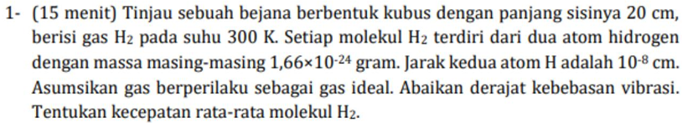
Diketahui:
L= 20 cm
T = 300K
M = 1,66 x 10^(-24) g -> kg
Jarak atom = 10^(-8) cm
Dicari kecepatan rata2 molekul = ?
$$\left\langle v\right\rangle =\sqrt{\frac{8RT}{πMr}}=\sqrt{\frac{8kT}{πm}}$$
$$\left\langle v\right\rangle =\sqrt{8×1,38×{10}^{-23}×300÷\left(3,14×3,32×{10}^{-27}\right)}=1,782×{10}^{3}\frac{m}{s}$$

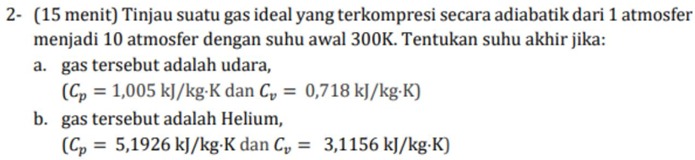

Diketahui:
Adiabatis
P1 = 1 atm
P2 = 10 atm
T1 = 300K
T2 = ?
Penyelesaian:
$$Rumus adiabatis:$$
$$P_{1}V_{1}^{γ}=P_{2}V_{2}^{γ}…….(1)$$
$$\left(mono:1,67;diatomik:1,4\right)$$
$$Rumus gas ideal:$$
$$PV=nRT$$
$$V=\frac{nRT}{P}…..\left(2\right)$$
Subtitusikan pers 1 dan 2:
$$\frac{P_{1}{\left(nR\right)}^{γ}T_{1}^{γ}}{P_{1}γ}=\frac{P_{2}{\left(nR\right)}^{γ}T_{2}^{γ}}{P_{2}γ}$$
$$P_{1}^{1-γ}T_{1}^{γ}=P_{2}^{1-γ}T_{2}^{γ}$$
$$T_{2}=T_{1}{\left(\frac{P_{1}}{P_{2}}\right)}^{\frac{1-γ}{γ}}$$
- Udara/02:
$$T_{2}=300{\left(\frac{1}{10}\right)}^{\frac{1-1,4}{1,4}}=579K.$$
- Helium: $T_{2}=300{\left(\frac{1}{10}\right)}^{\frac{1-1,67}{1,67}}=756K.$

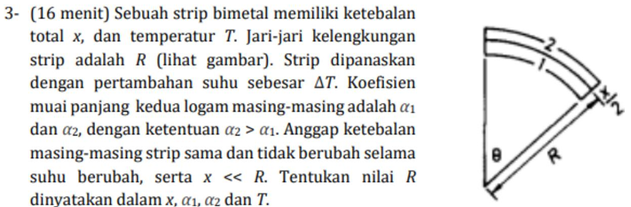

Diketahui:
Tebal = x
Temperatur = T
Jari2 = R
Penyelesaian:
$$Rumus pemuaian:$$
$$l_{1}=l_{0}(1+α_{1}ΔT)$$
$$l_{2}=l_{0}(1+α_{2}ΔT)$$
$$Rumus melingkar:$$
$$l_{1}=R_{1}θ; θ=rad$$
$$l_{2}=R_{2}θ$$
$$l_{1}=\left(R-\frac{x}{4}\right)θ$$
$$l_{2}=\left(R+\frac{x}{4}\right)θ$$

Kita subtitusikan rumus pemuaian dan melingkar:
Kita asumsikan selisih dari panjang $l_{2}-l_{1}$itu sama antara rumus pemuaian dan rumus melingkar:
Jadi,
$$Rumus pemuaian=rumus melingkar$$
$$l_{2}-l_{1}=l_{2}-l_{1}$$
$$l_{0}\left(1+α_{2}ΔT\right)-l_{0}\left(1+α_{1}ΔT\right)=\left(R+\frac{x}{4}\right)θ-\left(R-\frac{x}{4}\right)θ$$
$$l_{0}\left(α_{2}-α_{1}\right)ΔT=\frac{x}{2}θ$$
Karna:
$$l_{0}=Rθ (rumus dasar melingkar)$$
Kita subtitusikan:
$$Rθ\left(α_{2}-α_{1}\right)ΔT=\frac{x}{2}θ$$
$$R\left(α_{2}-α_{1}\right)ΔT=\frac{x}{2}$$
$$R=\frac{x}{\left(α_{2}-α_{1}\right)ΔT}$$

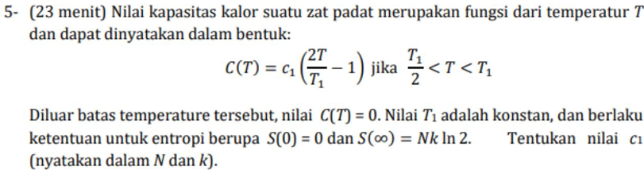
Penyelesaian:
$$Rumus entropi:$$
$$dS=\frac{C\left(T\right)}{T}dT$$
$$karna di soal ada nilai S\left(∞\right), maka kita pakai$$
$$\int_{0}^{∞}{dS=\int_{0}^{∞}{\frac{C\left(T\right)}{T}dT}}$$
$$S\left(∞\right)-S\left(0\right)=\int_{0}^{∞}{\frac{C\left(T\right)}{T}dT}$$
$$S\left(∞\right)=\int_{0}^{∞}{\frac{C\left(T\right)}{T}dT}$$
$$karna ada batasan T suhu di soal, maka kita pakai batasan tersebut.$$
$$S\left(∞\right)=\int_{\frac{T_{1}}{2}}^{T_{1}}{\frac{C\left(T\right)}{T}dT}$$

Kita masukkan nilai C(T):
$$S\left(∞\right)=\int_{\frac{T_{1}}{2}}^{T_{1}}{\frac{c_{1}(\frac{2T}{T_{1}}-1)}{T}dT}$$
$$S\left(∞\right)=c_{1}\int_{\frac{T_{1}}{2}}^{T_{1}}{(\frac{2}{T_{1}}-\frac{1}{T})dT}$$
$$S\left(∞\right)=c_{1}{\left[\frac{2T}{T_{1}}-\ln{T}\right]}_{\frac{T_{1}}{2}}^{T_{1}}=c_{1}(1-\ln{2})$$
Kita subtitusikan S:
$$Nk\ln{2=c_{1}(1-\ln{2})}$$
$$c_{1}=\frac{Nk\ln{2}}{1-\ln{2}}$$

